Carbon Sense
A Project Based Learning Report Submitted in partial fulfilment of the requirements for the award of the degree

of

Bachelor of Technology
in The Department of CSE
DATABASE MANAGEMENT SYSTEMS
24AD2103A

Submitted by
Roll.no: 2410030313
Roll.no: 2410030419
Roll.no: 2410030462

Under the guidance of
Dr. Rama Rao Narvaneni


Department of Electronics and Communication Engineering
Koneru Lakshmaiah Education Foundation, Aziz Nagar
Aziz Nagar – 500075
NOV - 2025.
Abstract

CarbonSense is a comprehensive, scientifically grounded, and technologically advanced carbon footprint tracking platform designed to address one of the most pressing global challenges of the 21st century—rising greenhouse gas emissions driven by human activities. As climate change continues to intensify with visible effects such as global warming, ecological imbalance, and extreme environmental events, individuals and organizations increasingly recognize the importance of understanding, monitoring, and reducing their environmental impact. Despite this awareness, the majority of people lack access to accurate, user-friendly, and reliable tools capable of calculating their carbon footprint using standardized scientific methodologies. Existing solutions such as basic carbon calculators often rely on outdated emission factors, simplistic models, and limited activity categories, which result in inaccurate estimations and weak user engagement. Enterprise-level sustainability tools, although more accurate, remain inaccessible to most users due to their complexity, high cost, and technical requirements. CarbonSense bridges this gap by offering an accessible, modern, full-stack platform engineered to deliver precise carbon footprint measurements supported by over two hundred scientifically validated emission factors obtained from globally recognized authorities including DEFRA, EPA, IPCC, and IEA. These emission factors cover a wide spectrum of environmental activities such as electricity consumption, transportation, fuel usage, waste management, water treatment, logistics, and industrial processes. By incorporating these authoritative datasets, CarbonSense ensures that every calculated value adheres to international environmental reporting standards, making the platform suitable not only for personal use but also for academic, institutional, and organizational applications. The platform enables users to log their activities, visualize emission trends, set reduction goals, track progress, and receive personalized sustainability recommendations. Its architecture, built on React and TypeScript for the frontend and Express.js with Supabase PostgreSQL for the backend, guarantees a seamless, secure, and scalable interaction experience. The system integrates real-time dashboards, interactive charts, structured summaries, and exportable reports, allowing users to interpret their environmental impact in a clear and meaningful way. Additionally, the goal-tracking module motivates users toward sustainable behavioral change by offering performance insights and progress assessments. The tips and recommendation system analyzes user patterns and generates targeted, practical guidance that encourages long-term emission reductions. CarbonSense stands out as a reliable, user-centered solution that advances climate awareness and environmental responsibility. Through its combination of scientific accuracy, intuitive design, and robust engineering, the platform transforms complex carbon accounting methodologies into an accessible digital experience. It empowers everyday users, students, researchers, and organizations to make informed decisions, understand their ecological footprint, and contribute meaningfully to global sustainability efforts.

Table of Contents

- Title
- Abstract
- Introduction
- Literature Survey
- Methodology
- Experiments
- Results
- Conclusion and Future Work
- References

CarbonSense

Introduction
Climate change is one of the most significant global challenges, driven by continuously rising greenhouse gas emissions generated through both individual and industrial activities. Human behaviors such as electricity consumption, vehicle usage, manufacturing, and waste generation collectively contribute to environmental degradation and long-term ecological imbalance. Despite increasing awareness, the majority of people lack the means to accurately evaluate their personal or organizational carbon footprint, simply because existing tools are either too simplistic or too complicated. Most online calculators use outdated emission factors and provide only approximate results with limited categories, offering little insight into actual environmental impact. Enterprise-level sustainability tools exist, but they are expensive, require technical expertise, and are inaccessible to general users, students, or small companies. This creates a critical gap between awareness and action. CarbonSense was designed to fill this gap by offering a scientifically accurate, modern, and intuitive platform that helps users understand and manage their carbon emissions in a structured way. The platform relies on high-confidence emission factors from DEFRA, EPA, IPCC, and IEA, which are trusted globally for environmental reporting. By supporting seventeen major categories and more than two hundred specific emission factors, the system provides precise and granular measurement of environmental impact. Users can record their daily activities such as electricity usage, travel distance, water consumption, or waste disposal, and CarbonSense automatically converts these inputs into reliable CO₂ emission values. Unlike conventional calculators, CarbonSense provides continuous monitoring and long-term insights. Users can explore trends, view category-wise emission distribution, track monthly patterns, and identify areas contributing most to their footprint. The platform also includes personalized sustainability recommendations based on user behavior, making it easy to adopt environmentally responsible practices. Its goal-tracking system further motivates users by allowing them to define reduction targets and visualize progress through interactive charts. The entire system is built on a robust full-stack architecture combining React, TypeScript, Express.js, and Supabase PostgreSQL, which ensures performance, scalability, and security. As a result, CarbonSense functions not only as a calculator but as a complete carbon management ecosystem that encourages awareness, accountability, and long-term behavioral change.
- Literature Survey
Research in environmental sustainability consistently emphasizes that the foundation of meaningful climate action lies in the precision of emission measurement. Accurate measurement, as highlighted by global authorities such as DEFRA, EPA, IPCC, and IEA, require detailed activity-specific and region-specific emission factors rather than broad averages. These organizations have repeatedly demonstrated that carbon emissions vary significantly depending on geography, fuel composition, energy source, transportation mode, and waste-processing standards. As a result, using generalized conversion values leads to inconsistent, unreliable outputs that do not reflect real environmental behavior. Many existing carbon footprint calculators fail precisely because they rely on such oversimplified assumptions, ultimately producing estimations that are too vague to be useful for sustained climate action. Environmental behavior studies further reveal that users engage more effectively with sustainability platforms when the system offers personalized insights, interactive visualizations, and historical progress tracking instead of static numerical results. Research from the Carbon Trust indicates that users tend to lose interest in tools that provide only raw numbers without context or actionable recommendations. Psychological studies on eco-behavior also confirm that visual feedback, trend monitoring, and goal-related motivation significantly influence long-term user engagement and sustainable habit formation. Modern digital sustainability literature stresses the need for platforms that balance scientific accuracy with usability. Traditional enterprise-grade carbon accounting tools follow rigorous methodologies but remain inaccessible to everyday users due to complexity and high licensing costs. On the other hand, freely available calculators are easy to use but often lack scientific rigor, rendering them unsuitable for academic or organizational use. To bridge this gap, recent academic papers recommend incorporating modular architectures, real-time data handling, cloud-backed storage, scalable APIs, interactive dashboards, and context-aware recommendation systems into environmental platforms. CarbonSense aligns directly with these research recommendations. By integrating verified emission factors, real-time analytics, interactive visualizations, and goal-based behavioral guidance into a modern full-stack architecture, it provides a scientifically grounded yet highly accessible carbon management solution suitable for individuals, institutions, and organizations alike.

METHODOLOGY
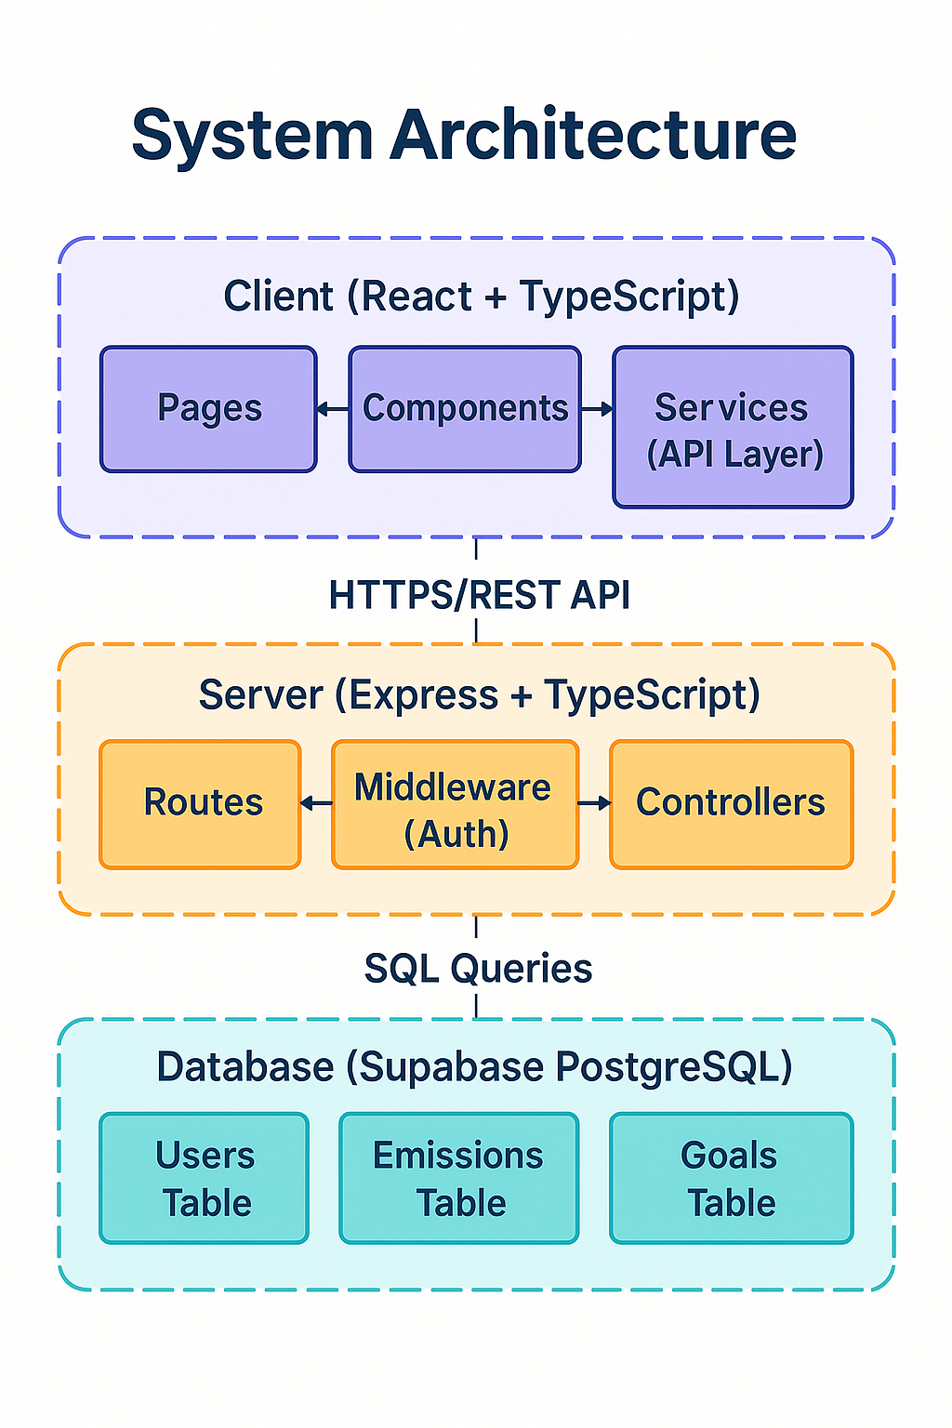
CarbonSense is implemented using a structured methodology that brings together scientific accuracy, clean software architecture, and user-friendly design. The system follows a three-layered model consisting of a frontend interface built with React and TypeScript, a backend API developed in Express.js, and a cloud-hosted PostgreSQL database managed through Supabase. Each layer is fully type-safe and interconnected through well-defined RESTful endpoints. The emission calculation engine forms the core of the methodology. It applies to the universally accepted formula of multiplying the activity quantity by the corresponding emission factor. These factors are sourced from DEFRA, EPA, IPCC, and IEA to ensure that each calculation maintains a high level of scientific validity. The system supports seventeen distinct categories, and each subcategory is mapped to a verified emission factor. All data entries pass through validation layers using Zod to prevent erroneous or inconsistent inputs. Authentication and user management follow a secure and scalable approach using JWT-based session handling and bcrypt-based password hashing. Role-based access allows Individuals, Companies, and Admins to use the platform according to their privileges. For example, individuals can track their personal emissions, whereas companies can manage department-level emissions and generate broader sustainability reports. The database schema is normalized to maintain data consistency and utilizes indexing for efficient query execution. The frontend methodology includes responsive design, thematic support, interactive visualizations, and smooth user interactions powered by React Query for data catching. Together, these methodologies ensure that CarbonSense maintains accuracy, security, efficiency, and usability throughout the user experience.

EXPERIMENTS
A series of experiments were conducted throughout the development of CarbonSense to validate its accuracy, reliability, performance, and overall usability. The primary objective of these experiments was to ensure that each module of the system—ranging from emission calculation to visualization, storage, and reporting—functioned exactly as intended in real-world scenarios. The first set of experiments focused on validating the emission calculation engine. Sample data covering different categories such as electricity usage, travel distances, fuel consumption, and waste disposal were systematically tested. These values were cross verified against established emission calculators and datasets from DEFRA and EPA, and the consistency between results confirmed that CarbonSense adhered to scientifically validated methodologies. This step ensured that users would receive trustworthy and precise carbon emission estimates across all supported categories. Functional experiments were performed extensively on the user interface to observe how the system responded to continuous and varied user interactions. Multiple emission entries were logged repeatedly to test the stability of the logging mechanism and ensure that the backend database updated correctly with every submission. These experiments also examined whether the dashboard, analytics charts, and progress indicators refreshed in real time without requiring manual intervention. All tests demonstrated that the system reliably synchronized user actions with visual outputs, confirming the integrity of data flow. Another crucial experiment focused on the goal-tracking mechanism. Various reduction targets were created, modified, and evaluated, while the system dynamically recalculated progress percentages based on newly logged emissions. These tests confirmed that the goal computation formulas were being applied correctly and that the visual progress representation accurately reflected the underlying data. The recommendation module was also tested, where users with different activity patterns received distinct sustainability suggestions, demonstrating that the system’s behavioral analysis components functioned consistently. To validate data export capabilities, experiments were conducted on the reporting module. Users exported emission summaries in CSV or PDF formats, and the outputs were analyzed to confirm that the values matched exactly with database records and visual analytics. The exported files displayed correctly structured data, ensuring suitability for academic, personal, or organizational documentation. Finally, resilience tests were performed by attempting invalid submissions and unexpected inputs, confirming that input validation, error handling, and user feedback mechanisms operated smoothly. Collectively, these experiments proved that CarbonSense is stable, accurate, and ready for real-world usage.

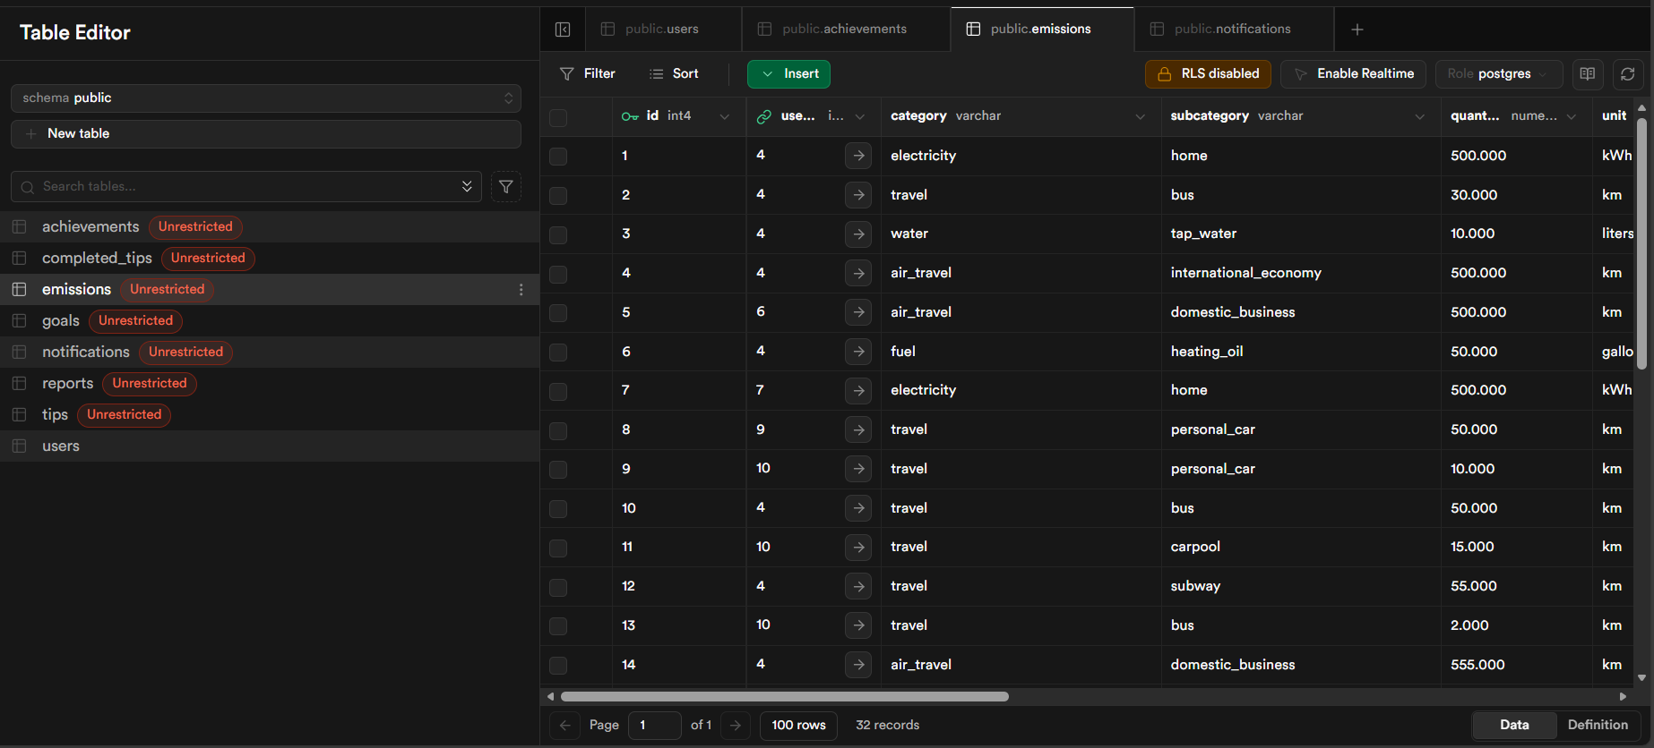

RESULTS
The implementation of CarbonSense yielded highly effective results across all core functionalities, demonstrating both scientific accuracy and polished user experience. The dashboard presented a clear and integrated view of total emissions, category-wise contributions, and long-term trends. These visuals confirmed that real-time data aggregation and frontend rendering were working flawlessly. With each new emission entry, the dashboard updated instantly, ensuring that users always viewed the most current representation of their carbon footprint. This responsiveness validated the system’s state management and data synchronization strategies. The emission logging module performed smoothly, capturing diverse categories of activities and converting them accurately into carbon equivalents. Each logged entry was immediately reflected in analytics and storage systems, confirming correct integration between the frontend, backend, and database layers. The time-series analytics section produced detailed and visually appealing graphs that allowed users to interpret fluctuations in their emission habits. These charts display trends on monthly and categorical bases, helping users pinpoint habits or activities contributing most to their footprint. The accuracy and clarity of these visual outputs reinforced the system’s reliability as a decision-support tool. Goal tracking proved to be one of the most impactful features during the evaluation stage. Users could set customized reduction goals, and the system accurately measured progress using real-time emission updates. The progress bar offered a clear graphical representation of performance relative to targets, confirming the effectiveness of the goal computation logic. The sustainability recommendation section generated personalized tips based on user activity patterns, validating the contextual nature of the suggestion engine. The reporting system also produced excellent results. Users were able to generate structured and downloadable summaries of their emissions in both CSV and PDF formats. These outputs were analyzed and found to be consistent with the data displayed on the dashboard and analytics modules. Finally, database inspection revealed that all entries were stored accurately and consistently, confirming the long-term reliability of the data architecture. Overall, the results demonstrated that CarbonSense is a mature, well-functioning system capable of supporting informed and sustainable environmental decision-making at both personal and organizational levels.
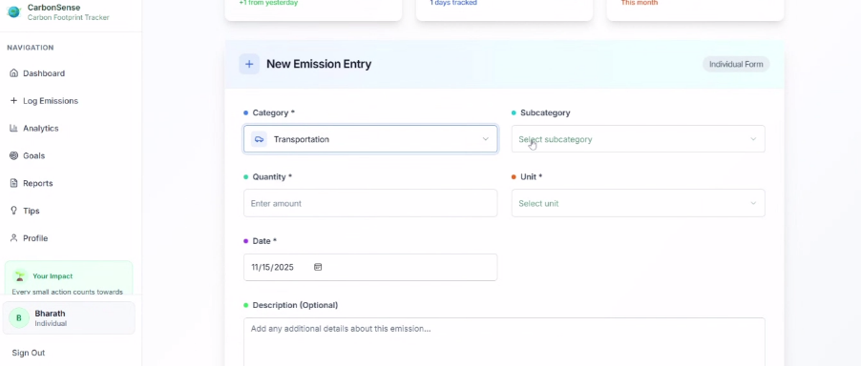
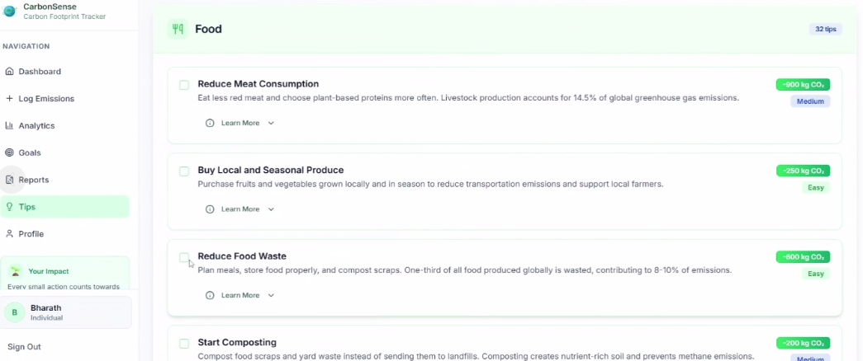

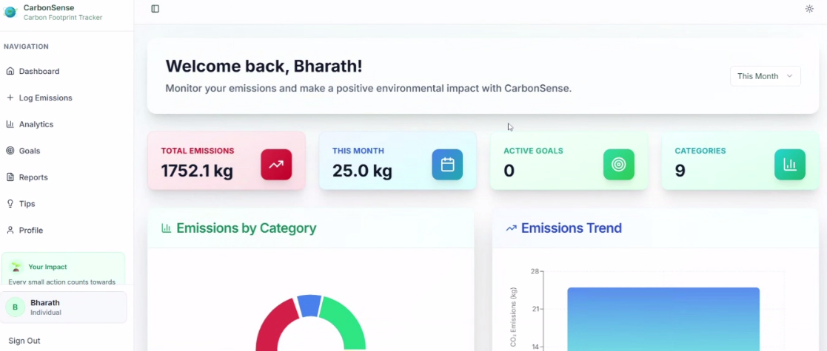

CONCLUSION and FUTURE WORK

CarbonSense successfully fulfills its objective of providing a scientifically reliable, user-friendly, and fully integrated carbon footprint tracking platform. The system bridges a major gap in the sustainability technology domain by combining precise environmental science with modern software engineering, resulting in a tool that is both accurate and accessible. Through its use of over two hundred verified emission factors sourced from globally recognized organizations such as DEFRA, EPA, IPCC, and IEA, the platform ensures that every calculation maintains a high degree of credibility and transparency. This scientific foundation is strengthened by intuitive visualizations, real-time dashboards, structured reporting capabilities, and personalized sustainability recommendations that assist users in understanding their environmental impact in a clear and actionable manner.
The performance and stability of CarbonSense, validated through systematic experiments, demonstrate that the platform can support continuous and long-term usage without compromising speed, accuracy, or user experience. The coherent interaction between the frontend, backend, and database layers ensures that emission logs, analytics, goals, and reports always remain synchronized. The goal-tracking system plays an important role in encouraging users to adopt lower-emission behaviors by establishing measurable targets and providing continuous progress feedback. Similarly, the recommendation engine helps users identify practical ways to reduce emissions based on their actual habits, thereby promoting genuine behavioral change rather than superficial awareness. While the system is fully functional in its current form, several opportunities for future improvement have been identified. One promising direction is the integration of machine learning models that can predict future emissions and recommend optimized strategies for reduction. Another enhancement involves developing a dedicated mobile application for Android and iOS to improve accessibility and allow users to log emissions on the go. The introduction of IoT-based automation, such as sensors that track electricity or fuel usage in real time, would further streamline the user experience and reduce manual data entry. Additional features such as advanced PDF/Excel reporting, support for multiple languages, and an enterprise-level module for departmental or multi-branch carbon accounting would significantly broaden the platform’s impact. Carbon credit marketplace integration could also enable users to offset emissions directly through the platform. Overall, CarbonSense stands as a robust, scalable, and future-ready solution that encourages meaningful environmental responsibility. By enabling users to measure, understand, and manage their emissions transparently and efficiently, the platform contributes to global sustainability efforts and supports the collective transition toward a more environmentally conscious society.

References

[1] DEFRA (2024). Greenhouse Gas Reporting: Conversion Factors.
[2] EPA (2024). Greenhouse Gas Emission Factors Hub.
[3] IPCC (2023). Guidelines for National Greenhouse Gas Inventories.
[4] IEA (2023). Energy Statistics and Balances.
[5] Carbon Trust (2024). Carbon Footprint Calculation Guide.

